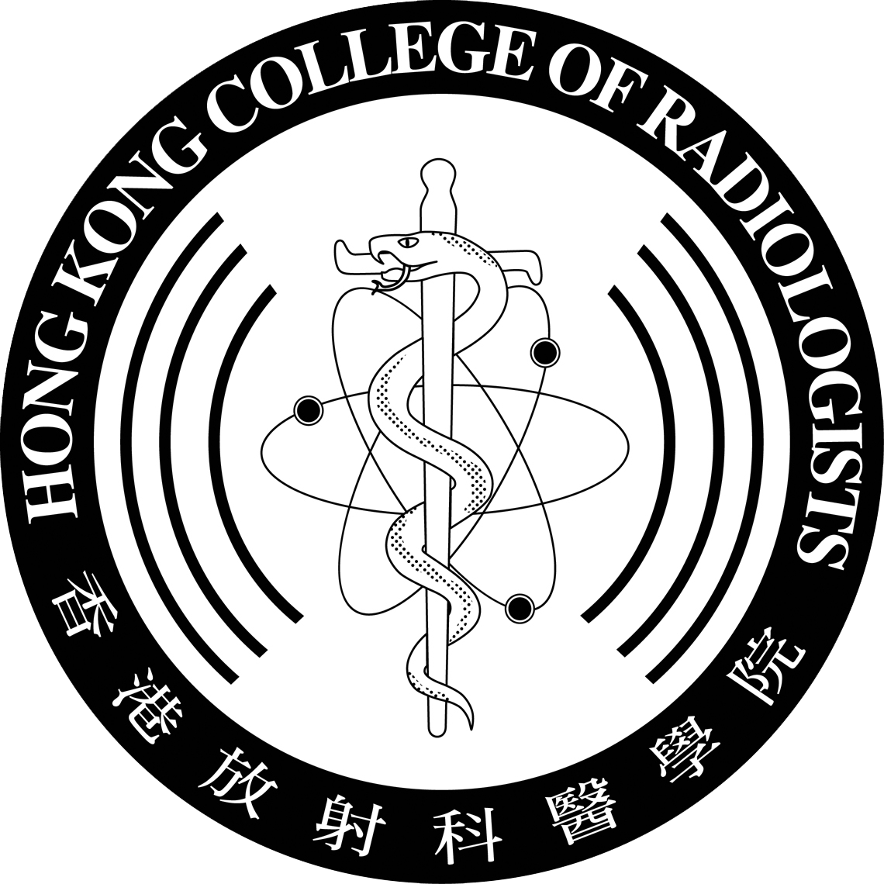 | HONG KONG COLLEGE OF RADIOLOGISTS  PALLIATIVE MEDICINE SUBSPECIALTY  TRAINEE REGISTRATION FORM  (PLEASE PRINT OR TYPE)

*To be completed by trainee doctors at the commencement of training for Palliative Medicine Subspecialty under Clinical Oncology of the Hong Kong College of Radiologists.

*Registration with The Medical Council of Hong Kong (MCHK) and Passing the Intermediate Examination in Clinical Oncology are essential before the training can commence.

Surname |  | Date of Birth
Other Names (In Full) |  | Gender
Correspondence Address
Telephone No. | (Office) | (Mobile)
E-mail Address
Degrees and Medical Qualifications (with Exact Dates)
Medical School where Qualified
Date of Passing the Intermediate Examination in Clinical Oncology
∗Expected Date / Date of Obtaining the Fellowship of Hong Kong College of Radiologists in Clinical Oncology (FHKCR)
(Please delete as appropriate)
Registration with The Medical Council of Hong Kong (MCHK) |  | (Date) | (Reg. No.)
Type of Registration under the General Register with MCHK

PLEASE TURN OVER
PLEASE GIVE BELOW DETAILS OF THE APPOINTMENT IN WHICH YOU WILL BE UNDERTAKING TRAINING
POST (Indicate if Honorary) | HOSPITAL | EXACT APPOINTMENT DATE
If training is to be undertaken on a part-time basis the number of sessions per week should be indicated.
To qualify for “part-time training”, not less than 5 sessions per week should be dedicated to training in Palliative Medicine.

Date: |  | Signature:

After completion, this form should be returned to the Warden of the Hong Kong College of Radiologists through the Training Head of the Training Centre, who is requested to be responsible for verification of the authenticity of the data supplied by the trainee. The Training Head is also requested to inform the College once the trainee has discontinued his training with the centre or with the training programme.

Form submitted via: | Name: |  | Signature:
 | Post: |  | Date:

