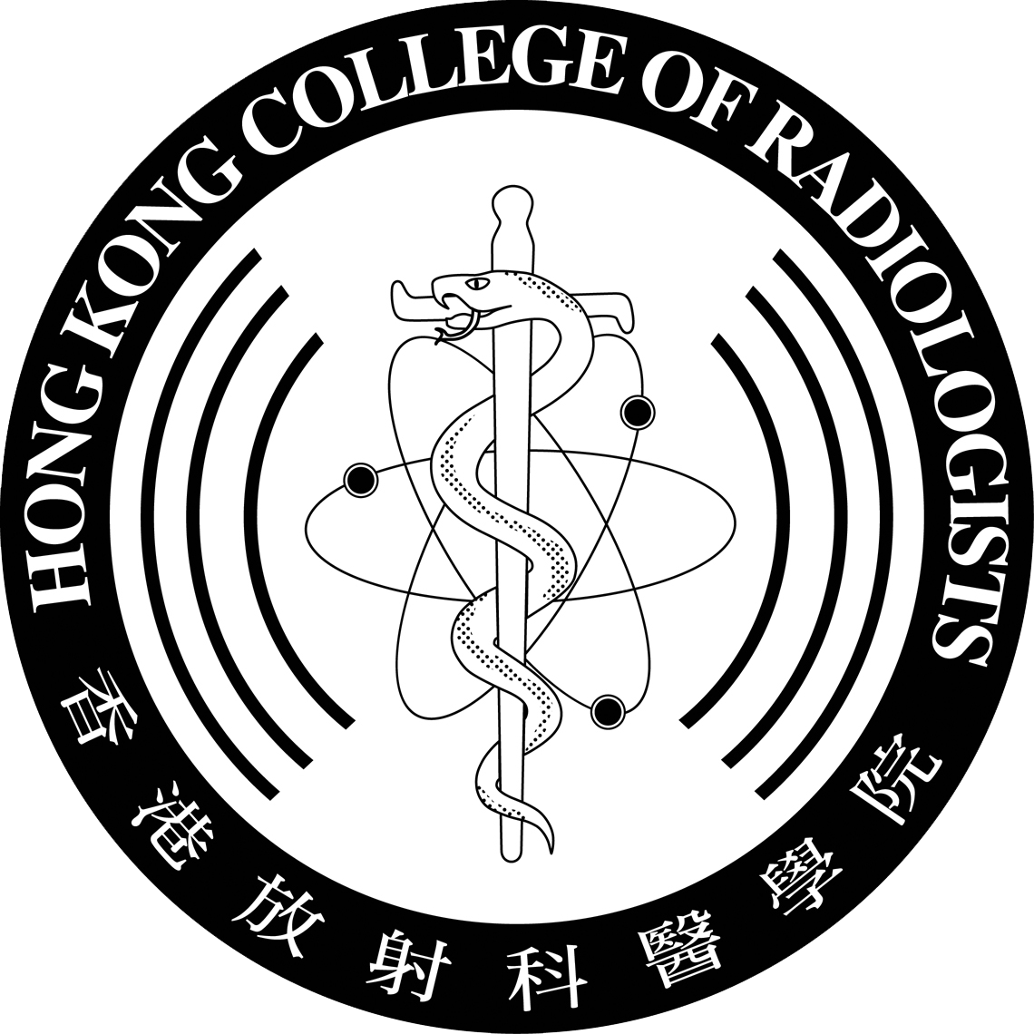 | HONG KONG COLLEGE OF RADIOLOGISTS  TRAINEE REGISTRATION FORM  (PLEASE PRINT OR TYPE)

* To be completed by trainee doctors at the commencement of training for the Fellowship of the Hong Kong College of Radiologists in Radiology, Clinical Oncology or Nuclear Medicine.

* Please note that completion of this form does NOT assume membership of the College. A separate application is required for admission as “Trainee Membership” of the College.

* Registration with the Medical Council of Hong Kong (MCHK) must be obtained before training in Hong Kong can commence.

Surname |  | Date of Birth
Other Names (In Full) |  | Gender
Correspondence Address
Telephone No. | (Office) | (Mobile)
E-mail Address
Degrees and Medical Qualifications (with Exact Dates)
Medical School where Qualified
Registration with The Medical Council of Hong Kong (MCHK) |  | (Date) | (Reg. No.)
Type of Registration under the General Register with MCHK |  | ☐ Full Registration  ☐ Limited Registration  ☐ Special Registration  ☐ Temporary Registration  ☐ Provisional Registration
State whether you will be training in  Radiology, Clinical Oncology or Nuclear Medicine  (Please tick the box where appropriate) |  | ☐ Radiology  ☐ Clinical Oncology  ☐ Nuclear Medicine

PLEASE GIVE BELOW DETAILS OF THE APPOINTMENT IN WHICH YOU WILL BE UNDERTAKING TRAINING
POST (Indicate if Honorary) | HOSPITAL | EXACT APPOINTMENT DATE

Had undergone post-registration clinical experience outside  Radiology / Clinical Oncology / Nuclear Medicine | ☐ Yes ☐ No
Duration of recognized clinical experience by HKCR

There is no exemption from full-time training for the first two years in the discipline. After the first two years, to qualify for “part-time training”, the trainee should satisfy a minimum requirement of 5 half-day sessions per week at approved training centres. Please refer to Training Regulations for details of other conditions pertinent to “part-time training”.

PLEASE TURN OVER
PLEASE GIVE BELOW DETAILS OF ALL CLINICAL APPOINTMENTS HELD (PRE-REGISTRATION AND POST-REGISTRATION) WITH EXACT DATES (IN CHRONOLOGICAL ORDER)

POST | SPECIALTY | HOSPITAL | EXACT DATES
 |  |  | FROM: / /
 |  |  | TO: / /
 |  |  | FROM: / /
 |  |  | TO: / /
 |  |  | FROM: / /
 |  |  | TO: / /
 |  |  | FROM: / /
 |  |  | TO: / /
 |  |  | FROM: / /
 |  |  | TO: / /
 |  |  | FROM: / /
 |  |  | TO: / /
 |  |  | FROM: / /
 |  |  | TO: / /
 |  |  | FROM: / /
 |  |  | TO: / /
 |  |  | FROM: / /
 |  |  | TO: / /

Date: |  | Signature:

After completion, this form should be returned to the Warden of the Hong Kong College of Radiologists through the Training Head of the Training Centre, who is requested to be responsible for verification of the authenticity of the data supplied by the trainee. The Training Head is also requested to inform the College once the trainee has discontinued his training with the centre or with the training programme.

Form submitted via: | Name: |  | Signature:
 | Post: |  | Date:

* This form should be completed by trainees who have previous accredited training on application to the College for
trainee registration.
* Applicants for trainee registration to commence the first year of training need NOT complete this form.

HONG KONG COLLEGE OF RADIOLOGISTS
TRAINEE REGISTER
Name:
Discipline: | ☐ Radiology  ☐ Clinical Oncology  ☐ Nuclear Medicine
Training Centre / Programme:
Date of first registration as Trainee in Radiology: | ☐ Hong Kong College of Radiologists Date:  ☐ The Royal College of Radiologists Date:  ☐ Others (Please specify): Date:

Training Period:

Date commencing | Date completed | Name of centre/programme

Attempts at Fellowship Examinations:

Date | Joint FRCR/FHKCR or FRCR | Part | Result

Exit Assessment:

Date | Result | Recommendation

Date : _______________________________ Signature : _________________________
(This form will be reserved for office use for first year new registrant.)

